87779147468
820719400541
БАЛГАБЕКОВА Гулсим Сарсеновна ,
Ө.жәнібеков атындағы №19 жалпы орта білім беретін мектебінің ағылшын тілі пәні мұғалімі.
Шымкент қаласы

VOLCANOES

Learning objectives | 4.3.6.1 understand basic information and detail in short simple texts about a wide range of general and learning topics with little support;  4.2.5.1 pronounce giving presentation clearly pronounce more words, short phrases and simple sentences;
Lesson objectives | Learners will be able to:  - To apply basic information and detail in short simple texts about the theme about volcanoes  - to present words, short phrases and  simple sentences from the theme about volcanoes
Value links | "Law and Order"  Ensuring the protection and safety of society understand the importance of law and order as
Plan

Stages / Time | Teachers actions | Students actions | Assessment criteria | Resources
Beginning of the lesson  Warming-up    3 min  Pre-learning  «Brainstorming» method  7 min. | Organization moment:  1.Greeting.  Ask about the weather.  Warming up:  Where are you from?  How old are you?  What color is it?  How many students are there in class?  What day of the week today?  Revise the language of the previous lesson  The teacher sets the lesson objectives,  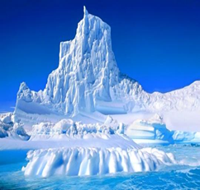  Show flashcards with volcano-related pictures and words.  Ok children! Lets review our todays new words  Volcano Жанартау  Lava Лава  Magma Магма  Eruption Атқылау  Mountain Тау  Fire Өрт  Hot Ыстық | Students of the class are listed. and repeat todays new words  Determines the topic and purpose of the lesson  Learners talk about lesson vocabulary  Do a quick! they will repeat new words. And they must write on dictionary.  "Listen and Point" or "What's this?" drill using the cards. | The teacher to assess learners for their ability.  “Good job!  Well done!”  Formative Assessment  Good job!  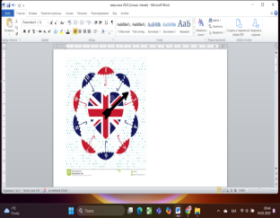 | Pictures  Flashcards  (Vocabulary words with pictures)
Middle of the lesson  Presentation part.  30 min | Ex:26 P:78  Say and write on the board snow and ice. Have a brief class discussion. Read aloud the words and elicit/explain any unknown vocabulary. Explain the activity. Allow the pupils some time to complete it. Check their answers.  "Law and Order"  Ensuring the protection and safety of society understand the importance of law and order as  Task 1: Sentence Building  Objective: Practice forming and pronouncing short phrases and simple sentences.  Task 2 Ex: 27 P: 78  Refer the pupils to the pictures, one at a time, and mave a class discussion. Play the CD. The pupils listen and follow in their books.  Task 3 Ex: 28 P: 79  Explain the activity. Allow the pupils some time to read The text again silently and correct the sentences  Task 4: Mini Presentation  Objective: Use vocabulary and simple sentences to talk about volcanoes.  Descriptor: Learners say short phrases or sentences (e.g., “Volcanoes can erupt.”) using correct pronunciation | Pupils choose and write on the igloo the words that have to do with snow and ice.  ANSWERS  Scarf, snowflake, penguin, winter, ice crystal      Pupils listen and read  ANSWERS  Students own answer  Pupils read again. Correct the sentences  Instructions: Provide word cards (e.g., “Volcanoes”, “are”, “hot”, “Lava”, “flows”, “down”).  Learners form correct simple sentences and read them aloud.  ANSWERS  2 ice/snow  3 volcano  4 blue whales  5 February  Pupils read, choose and complete.  ANSWERS  2 snowflakes  3 200  4 different  5 largest  Learners must divide In pairs or small groups, learners will prepare 2–3 sentences about volcanoes using visuals or drawings. They present to the class | Descriptor:  - write on the igloo the words  - check their answers  Total: 2 point  Descriptor:  - listen and read  Total: 2 point  Descriptor: Learners create 2–3 simple sentences about volcanoes and pronounce them clearly.  Descriptor:  - read again  - correct the sentences  Total: 2 point  Descriptor:  - read, choose and complete.  Total: 3 point  -Make CCQ questions Yes / No  Total: 10 point  Assessment Criteria for Mini Presentation | Criteria  1. Vocabulary Use Uses 3–4 key volcano-related words correctly (e.g., lava, eruption, hot, ash).  2. Sentence Formation |Forms 2–3 simple and clear sentences about volcanoes.  You can score each criterion on a simple 3-point scale:  - 3 – Excellent  - 2 – Satisfactory  - 1 – Needs support  Descriptor: Learners say short phrases or sentences (e.g., “Volcanoes can erupt.”) using correct pronunciation |   Card  Worksheet  Students book  Students book  Students book  Sheets of paper
End of the lesson  5 min | FEEDBACK  Learners provide feedback on what they have learned at the lesson.  Ex:  Home task: | 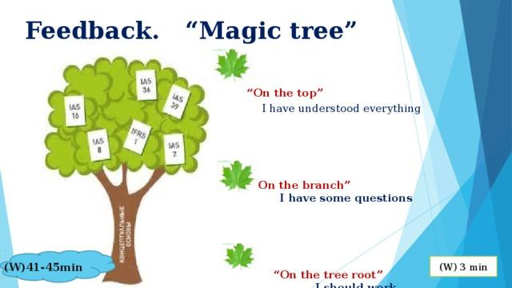 |  | Poster Success  

